**EXPERIMENT 4**

* **shell script that determines the period for which a specified user is working on the system.**

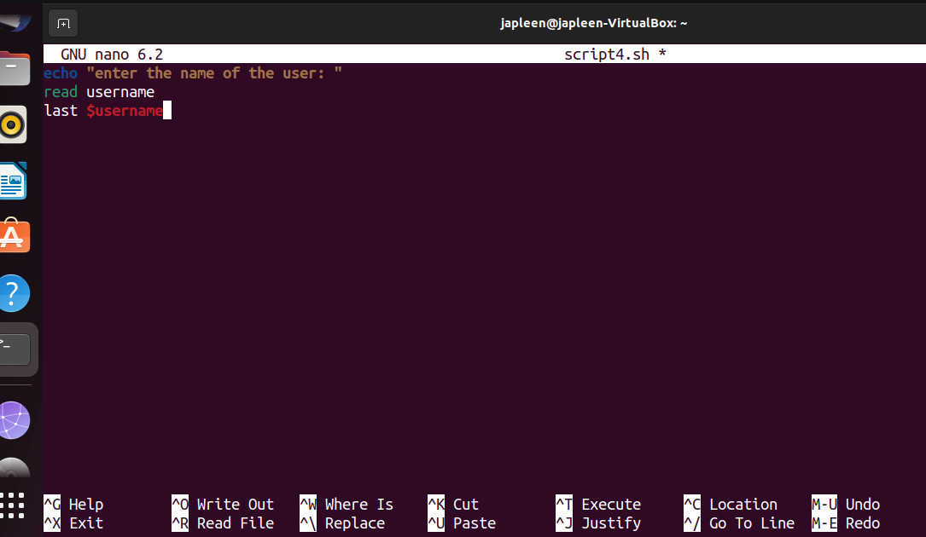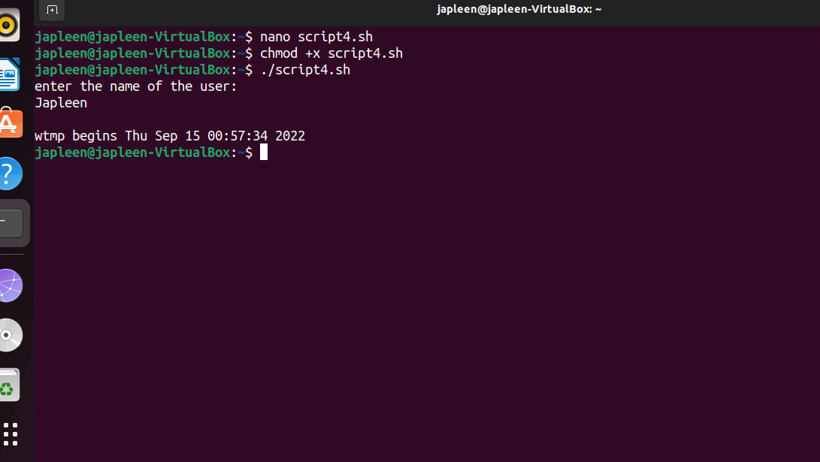

* **Shell script that displays all the lines between start and end line numbers passed as argument.**

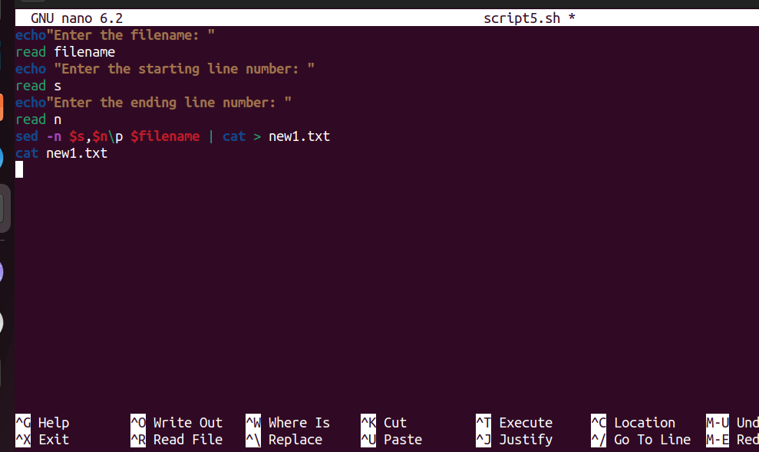

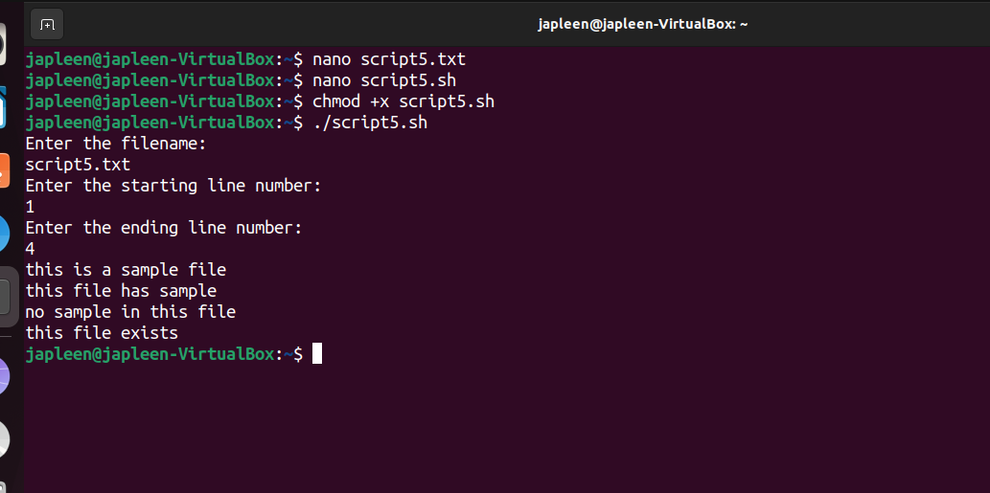

* **Shell script that deletes all lines containing a specified word in one or more files supplied as arguments to it**

